DRAFT
ENVIRONMENTAL ASSESSMENT
Checklist

Rambo Pivot Pond License Review
FWP-CEA-FSH-R4-24-008
3/27/2024



Table of Contents

I. Compliance with the Montana Environmental Policy Act 3
II. Background and Description of Proposed Project 3
III. Purpose and Need 5
IV. Other Agency Regulatory Responsibilities 5
V. List of Mitigations, Stipulations 6
VI. Alternatives Considered 6
VII. Summary of Potential Impacts of the Proposed Project on the Physical Environment and Human Population 7
VIII. Private Property Impact Analysis (Takings) 14
IX. Public Participation 15
X. Recommendation for Further Environmental Analysis 16
XI. EA Preparation and Review 16

Compliance with the Montana Environmental Policy Act
Before a proposed project may be approved, environmental review must be conducted to identify and consider potential impacts of the proposed project on the human and physical environment affected by the project. The Montana Environmental Policy Act (MEPA) and its implementing rules and regulations require different levels of environmental review, depending on the proposed project, significance of potential impacts, and the review timeline. § 75-1-201, Montana Code Annotated (“MCA”), and the Administrative Rules of Montana (“ARM”) 12.2.430, General Requirements of the Environmental Review Process.
FWP must prepare an EA when:
- It is considering a “state-proposed project,” which is defined in § 75-1-220(8)(a) as:
(i) a project, program, or activity initiated and directly undertaken by a state agency;
(ii) … a project or activity supported through a contract, grant, subsidy, loan, or other form of funding assistance from a state agency, either singly or in combination with one or more other state agencies; or
(iii) … a project or activity authorized by a state agency acting in a land management capacity for a lease, easement, license, or other authorization to act.
- It is not clear without preparation of an EA whether the proposed project is a major one significantly affecting the quality of the human environment. ARM 12.2.430(3)(a));
- FWP has not otherwise implemented the interdisciplinary analysis and public review purposes listed in ARM 12.2.430(2) (a) and (d) through a similar planning and decision-making process (ARM 12.2.430(3)(b));
- Statutory requirements do not allow sufficient time for the FWP to prepare an EIS (ARM 12.2.430(3)(c));
- The project is not specifically excluded from MEPA review according to § 75-1-220(8)(b) or ARM 12.2.430(5); or
- As an alternative to preparing an EIS, prepare an EA whenever the project is one that might normally require an EIS, but effects which might otherwise be deemed significant appear to be mitigable below the level of significance through design, or enforceable controls or stipulations or both imposed by the agency or other government agencies. For an EA to suffice in this instance, the agency must determine that all the impacts of the proposed project have been accurately identified, that they will be mitigated below the level of significance, and that no significant impact is likely to occur. The agency may not consider compensation for purposes of determining that impacts have been mitigated below the level of significance (ARM 12.2.430(4)).
MEPA is procedural; its intent is to ensure that impacts to the environment associated with a proposed project are fully considered and the public is informed of potential impacts resulting from the project.

Background and Description of Proposed Project

Name of Project: Rambo Pivot Pond License Review

A private landowner is applying for a Private Fish Pond License and proposes to stock brook trout, rainbow trout, brown trout and westslope cutthroat trout in an unnamed private pond. The pond is ~2 surface acre and is located on 8684 Ledger Rd, MT. The pond is located on a coulee of a tributary to the Dry Fork Marias River near the town of Ledger, MT with no known presence of fish existing in the pond. The pond is fed by overland snow melt and drainage from nearby fields. There is no established outlet but there is a slight overflow channel that navigates water into the coulee. The overflow discharge is rare and flows ~2.1 miles down the unnamed coulee to the Dry Fork of the Marias which flows ~7 miles into the Marias River upstream of Tiber Reservoir. Northern redbelly dace have been documented in the lower portion of the Dry Fork of the Marias and is the only documented Montana Species of Special Concern. Most trout species are not native to Dry Fork Marias River however, risk of escapement is low and associated risks are minimal, given existing presence in drainage. Westslope cutthroat trout are native to MT, but conservation populations are not present in drainage, presenting no adverse genetic effects with wild fish. Fish could be removed from the pond via chemical treatments or stocking can be stopped to let the fish age out. The project is sponsored by the private landowner and the license would be active for a period of 10 years from the year of issuance (2024). The license can be renewed for additional 10-year intervals at the end of each term and the license is transferable.
Affected Area / Location of Proposed Project:
- Legal Description
  - Latitude/Longitude: 48.26502, -111.7811
  - Section, Township, and Range: Section 29, Township 1 N, Range 18W
  - Town/City, County, Montana: Ledger, Pondera County, Montana
- Location Map
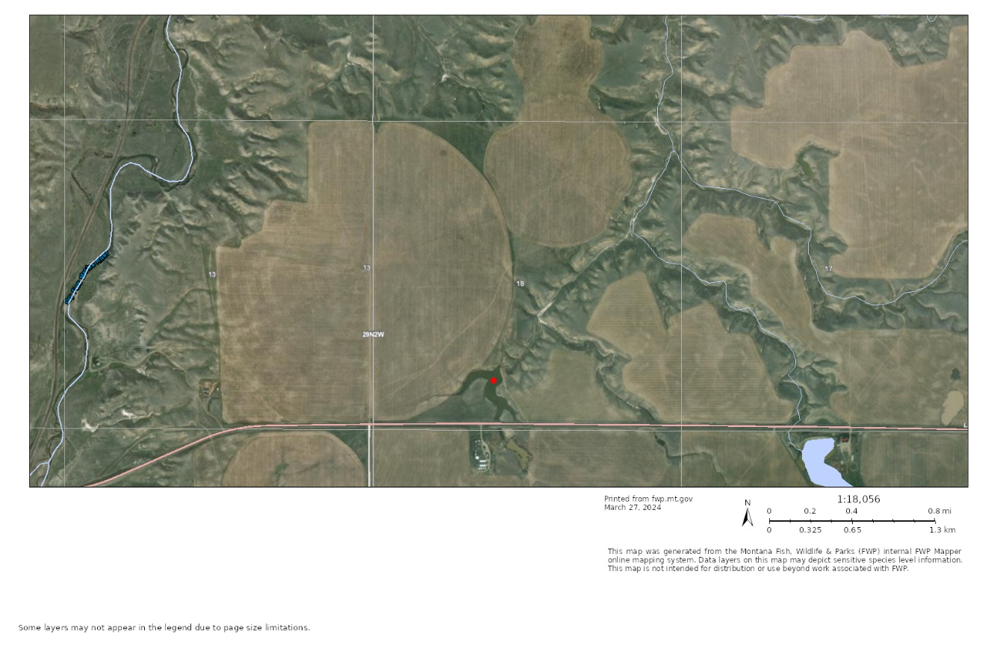
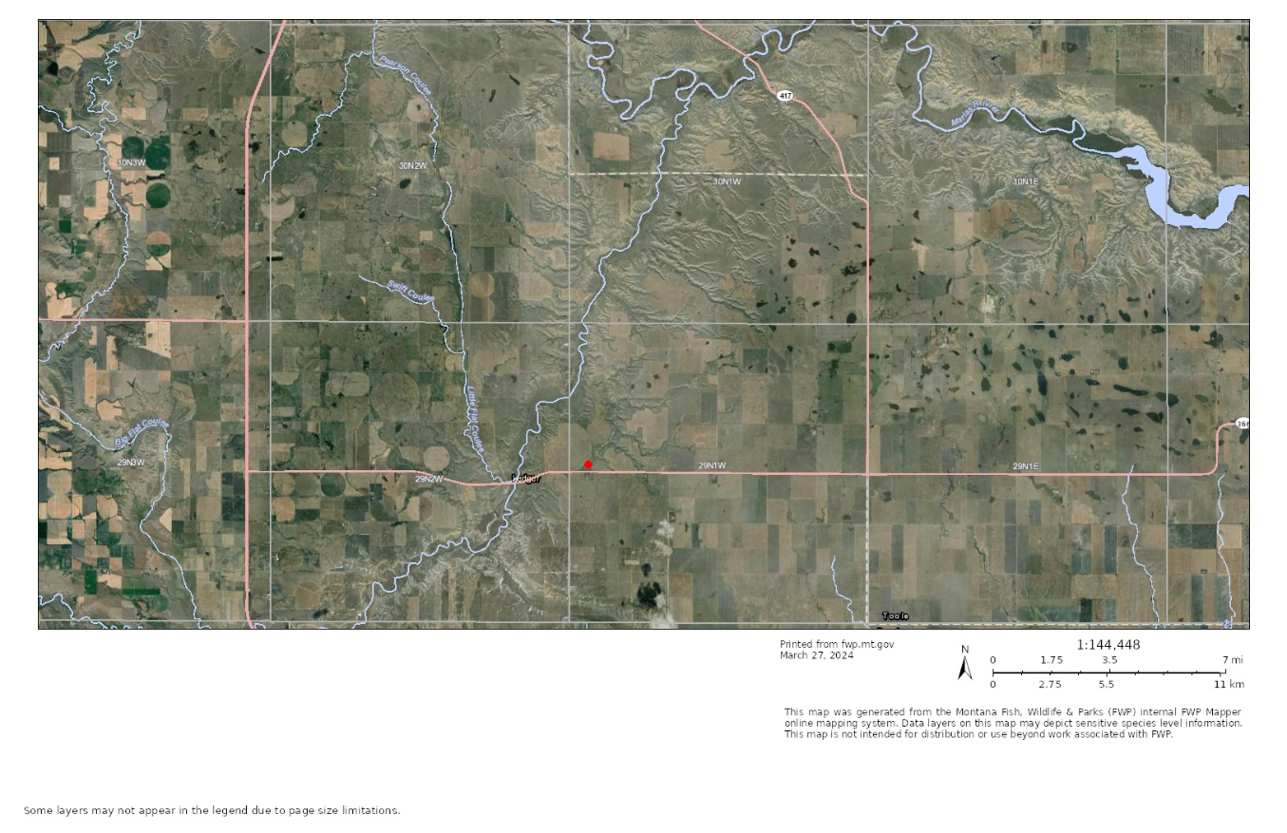

Purpose and Need
The EA must include a description of the purpose and need or benefits of the proposed project. ARM 12.2.432(3)(b). Benefits of the proposed project refer to benefits to the resource, public, department, state, and/or other.
The purpose is for a private landowner to stock brook trout, rainbow trout, brown trout and westslope cutthroat trout in the private pond located at 29N1W18
If FWP prepared a cost/benefit analysis before completion of the EA, the EA must contain the cost/benefit analysis or a reference to it. ARM 12.2.432(3)(b).
 | Yes* | No
Was a cost/benefit analysis prepared for the proposed project? | ☐ | ☒
* If yes, a copy of the cost/benefit analysis prepared for the proposed project is included in Attachment A to this Draft EA

Other Agency Regulatory Responsibilities
FWP must list any federal, state, and/or local agencies that have overlapping or additional jurisdiction, or environmental review responsibility for the proposed project, as well as permits, licenses, and other required authorizations. ARM 12.2.432(3)(c).
A list of other required local, state, and federal approvals, such as permits, certificates, and/or licenses from affected agencies is included in Table 1 below. Table 1 provides a summary of requirements but does not necessarily represent a complete and comprehensive list of all permits, certificates, or approvals needed for the proposed project. Agency decision-making is governed by state and federal laws, including statutes, rules, and regulations, that form the legal basis for the conditions the proposed project must meet to obtain necessary permits, certificates, licenses, or other approvals. Further, these laws set forth the conditions under which each agency could deny the necessary approvals.
Table 1: Federal, State, and/or Local Regulatory Responsibilities
Agency | Type of Authorization (permit, license, stipulation, other) | Purpose
MT DNRC | Water Right | The State of Montana owns the waters within the state on behalf of its citizens. Citizens do not own the water but can possess a legal right to use the water within state guidelines. A legal water right exists for this waterbody – 41P 35896-00

List of Mitigations, Stipulations
Mitigations, stipulations, and other enforceable controls required by FWP, or another agency, may be relied upon to limit potential impacts associated with a proposed Project. The table below lists and evaluates enforceable conditions FWP may rely on to limit potential impacts associated with the proposed Project. ARM 12.2.432(3)(g).

Table 2: Listing and Evaluation of Enforceable Mitigations Limiting Impacts
Are enforceable controls limiting potential impacts of the proposed action? If not, no further evaluation is needed. |  |  | Yes ☐ | No ☒
If yes, are these controls being relied upon to limit impacts below the level of significance? If yes, list the enforceable control(s) below |  |  | Yes ☐ | No ☐
Enforceable Control | Responsible Agency | Authority (Rule, Permit, Stipulation, Other) | Effect of Enforceable Control on Proposed Project

Alternatives Considered
In addition to the proposed project, and as required by MEPA, FWP analyzes the "No-Action" alternative in this EA. Under the “No Action” alternative, the proposed project would not occur. Therefore, no additional impacts to the physical environment or human population in the analysis area would occur. The “No Action” alternative forms the baseline from which the potential impacts of the proposed Project can be measured.
 | Yes* | No
Were any additional alternatives considered and dismissed? | ☐ | ☒
* If yes, a list and description of the other alternatives considered, but not carried forward for detailed review is included below

Summary of Potential Impacts of the Proposed Project on the Physical Environment and Human Population
The impacts analysis identifies and evaluates direct, secondary, and cumulative impacts.
- Direct impacts are those that occur at the same time and place as the action that triggers the effect.
- Secondary impacts “are further impacts to the human environment that may be stimulated or induced by or otherwise result from a direct impact of the action.” ARM 12.2.429(18).
- Cumulative impacts “means the collective impacts on the human environment of the proposed action when considered in conjunction with other past and present actions related to the proposed action by location or generic type. Related future actions must also be considered when these actions are under concurrent consideration by any state agency through pre-impact statement studies, separate impact statement evaluation, or permit processing procedures.” ARM 12.2.429(7).
Where impacts are expected to occur, the impact analysis estimates the extent, duration, frequency, and severity of the impact. The duration of an impact is quantified as follows:
- Short-Term: impacts that would not last longer than the proposed project.
- Long-Term: impacts that would remain or occur following the proposed project.
The severity of an impact is measured using the following:
- No Impact: there would be no change from current conditions.
- Negligible: an adverse or beneficial effect would occur but would be at the lowest levels of detection.
- Minor: the effect would be noticeable but would be relatively small and would not affect the function or integrity of the resource.
- Moderate: the effect would be easily identifiable and would change the function or integrity of the resource.
- Major: the effect would irretrievably alter the resource.
Some impacts may require mitigation. As defined in ARM 12.2.429, mitigation means:
- Avoiding an impact by not taking a certain action or parts of a project;
- Minimizing impacts by limiting the degree or magnitude of a project and its implementation;
- Rectifying an impact by repairing, rehabilitating, or restoring the affected environment; or
- Reducing or eliminating an impact over time by preservation and maintenance operations during the life of a project or the time period thereafter that an impact continues.

A list of any mitigation strategies including, but not limited to, design, enforceable controls or stipulations, or both, as applicable to the proposed project is included in Section VI above.
FWP must analyze impacts to the physical and human environment for each alternative considered. The proposed project considered the following alternatives:
- Alternative 1: No Action. Evaluation and Summary of Potential Impacts on the Physical Environment and Human Population
Under the “No Action” alternative, the proposed project would not occur. Therefore, no additional impacts to the physical environment or human population in the analysis area would occur. The “No Action” alternative forms the baseline from which the potential impacts of the proposed Project can be measured.
The “No Action” alternative is to not provide a private pond license and not allow the stocking of brook trout, rainbow trout, brown trout and westslope cutthroat into the pond.

- Alternative 2: Proposed Project. Evaluation and Summary of Potential Impacts on the Physical Environment and Human Population
See Table 3 (Impacts on Physical Environment) and Table 4 (Impacts on Human Population) below.

Table 3 - Potential Impacts of Proposed Project on the Physical Environment
PHYSICAL ENVIRONMENT | Duration of Impact |  |  | Severity of Impact
Resource | None | Short-Term | Long-Term | None | Negligible | Minor | Moderate | Major | Summary of Potential Direct, Secondary, and Cumulative Impacts and Mitigation Measures
Terrestrial, avian, and aquatic life and habitats | ☐ | ☐ | ☒ | ☐ | ☐ | ☒ | ☐ | ☐ | Introduction of trout may result in short-term minor changes in species composition of the fish assemblage and aquatic invertebrate community, as well as trophic or food web level alterations within the project area. The duration of impact is short-term and long-term. Downstream impacts to the drainage are expected to be negligible given presence of brook trout within the drainage. Screening the outlet pipe will reduce downstream dispersal impacts.
Water quality, quantity, and distribution | ☒ | ☐ | ☐ | ☒ | ☐ | ☐ | ☐ | ☐ | No significant adverse impacts to water quality, quantity, and distribution would be expected because of the proposed project. The proposed project would not require the use of any additional new water resources, nor would it affect the distribution of any existing water resources.
Geology | ☒ | ☐ | ☐ | ☒ | ☐ | ☐ | ☐ | ☐ | No significant adverse impacts to geology would be expected because of the proposed project. The proposed project would not affect any geologic features in the project area; therefore, no impacts to geology would be expected because of the proposed project.
Soil quality, stability, and moisture | ☒ | ☐ | ☐ | ☒ | ☐ | ☐ | ☐ | ☐ | No significant adverse impacts to soil quality, stability, and moisture would be expected because of the proposed project. The proposed project would not affect soils; therefore, no impacts would be expected because of the proposed project.
Vegetation cover, quantity, and quality | ☒ | ☐ | ☐ | ☒ | ☐ | ☐ | ☐ | ☐ | No significant adverse impacts to vegetation cover, quantity, and quality would be expected because of the proposed project. The proposed project would not affect vegetation in the affected area; therefore, no impacts would be expected because of the proposed project.
Aesthetics | ☒ | ☐ | ☐ | ☒ | ☐ | ☐ | ☐ | ☐ | No significant adverse impacts to the aesthetic nature of the affected area would be expected because of the proposed project. The proposed project would not affect
Air quality | ☒ | ☐ | ☐ | ☒ | ☐ | ☐ | ☐ | ☐ | No significant adverse impacts to air quality would be expected because of the proposed project. The proposed project would not result in additional new air quality disturbance in the affected area.
Unique, endangered, fragile, or limited environmental resources | ☒ | ☐ | ☐ | ☒ | ☐ | ☐ | ☐ | ☐ | No significant adverse impacts to unique, endangered, fragile or limited environmental resources would be expected because of the proposed project. No impacts would be expected because of the proposed project.
Historical and archaeological sites | ☒ | ☐ | ☐ | ☒ | ☐ | ☐ | ☐ | ☐ | No significant adverse impacts to historic and archaeological sites would be expected because of the proposed project.
Demands on environmental resources of land, water, air, and energy | ☒ | ☐ | ☐ | ☒ | ☐ | ☐ | ☐ | ☐ | No significant adverse impacts to demands on the environmental resources of land, water, air, and energy would be expected because of the proposed project.

Table 4 - Potential Impacts of Proposed Project on the Human Population
HUMAN POPULATION | Duration of Impact |  |  | Severity of Impact
Resource | None | Short-Term | Long-Term | None | Negligible | Minor | Moderate | Major | Summary of Potential Direct, Secondary, and Cumulative Impacts and Mitigation Measures
Social structures and mores | ☒ | ☐ | ☐ | ☒ | ☐ | ☐ | ☐ | ☐ | The proposed project would not impact any pre-project social structures, customs, values, and conventions in the affected area.
Cultural uniqueness and diversity | ☒ | ☐ | ☐ | ☒ | ☐ | ☐ | ☐ | ☐ | No significant impacts to cultural uniqueness and diversity in the affected area would be expected because of the proposed project. No impacts to the existing cultural uniqueness and diversity of the affected area would be expected because of the proposed project.
Access to and quality of recreational and wilderness activities | ☐ | ☒ | ☐ | ☐ | ☒ | ☐ | ☐ | ☐ | Stocking brook trout and westslope cutthroat in this waterbody would improve the recreation value for the landowner and anyone they choose to provide access to. That impact is anticipated to be negligible and short-term lasting only while the fish are present.
Local and state tax base and tax revenues | ☐ | ☐ | ☒ | ☐ | ☒ | ☐ | ☐ | ☐ | No significant impacts to the local and state tax base and tax revenue would be expected because of the proposed project. The proposed project would require the purchase of trout for stocking but impact to the state and local tax revenues from the sale of the fish is anticipated to be negligible. Any impacts to the local and state tax base and tax revenue would be short -term and negligible, lasting only as long as the proposed project.
Agricultural or Industrial production | ☒ | ☐ | ☐ | ☒ | ☐ | ☐ | ☐ | ☐ | No significant impacts to agricultural or industrial production in the affected area would be expected because of the proposed project. No impacts would be expected because of the proposed project.
Human health and safety | ☒ | ☐ | ☐ | ☒ | ☐ | ☐ | ☐ | ☐ | No significant adverse impacts to human health and safety would be expected because of the proposed project. No impacts would be expected because of the proposed project.
Quantity and distribution of employment | ☒ | ☐ | ☐ | ☒ | ☐ | ☐ | ☐ | ☐ | No significant adverse impacts to the quantity and distribution of employment in the affected area would be expected because of the proposed project. No impacts would be expected because of the proposed project.
Distribution and density of population and housing | ☒ | ☐ | ☐ | ☒ | ☐ | ☐ | ☐ | ☐ | No significant adverse impacts to the distribution and density of population and housing would be expected because of the proposed project. No impacts would be expected because of the proposed project.
Demands for government services | ☒ | ☐ | ☐ | ☒ | ☐ | ☐ | ☐ | ☐ | No significant adverse impacts to the demands for government services in the affected area would be expected because of the proposed project. No impacts would be expected because of the proposed project.
Industrial, agricultural, and commercial activity | ☒ | ☐ | ☐ | ☒ | ☐ | ☐ | ☐ | ☐ | No significant adverse impacts to industrial, agricultural, and commercial activity would be expected because of the proposed project. No impacts to industrial, agricultural, or commercial activity would be expected because of the proposed project
Locally adopted environmental plans and goals | ☒ | ☐ | ☐ | ☒ | ☐ | ☐ | ☐ | ☐ | No significant adverse impacts to locally adopted environmental plans and goals would be expected because of the proposed project. No impacts to locally adopted environmental plans and goals would be expected because of the proposed project.
Other appropriate social and economic circumstances | ☒ | ☐ | ☐ | ☒ | ☐ | ☐ | ☐ | ☐ | No significant adverse impacts to any other appropriate social and economic circumstances would be expected because of the proposed project. FWP is unaware of any other appropriate social and economic circumstances that may be impacted by the proposed project. Therefore, no significant adverse impacts to other appropriate social and economic circumstances would be expected because of the proposed project.

Table 6: Determining the Significance of Impacts on the Quality of the Human Environment
If the EA identifies impacts associated with the proposed project FWP must determine the significance of the impacts. ARM 12.2.431. This determination forms the basis for FWP’s decision as to whether it is necessary to prepare an environmental impact statement. An impact may be adverse, beneficial, or both. If none of the adverse effects of the impact are significant, an EIS is not required. An EIS is required if an impact has a significant adverse effect, even if the agency believes that the effect on balance will be beneficial. ARM 12.2.431.

According to the applicable requirements of ARM 12.2.431, FWP must consider the criteria identified in this table to determine the significance of each impact on the quality of the human environment. The significance determination is made by giving weight to these criteria in their totality. For example, impacts identified as moderate or major in severity may not be significant if the duration is short-term. However, moderate or major impacts of short-term duration may be significant if the quantity and quality of the resource is limited and/or the resource is unique or fragile. Further, moderate or major impacts to a resource may not be significant if the quantity of that resource is high or the quality of the resource is not unique or fragile.
Criteria Used to Determine Significance
1 | The severity, duration, geographic extent, and frequency of the occurrence of the impact  “Severity” describes the density of the potential impact, while “extent” describes the area where the impact will likely occur, e.g., a project may propagate ten noxious weeds on a surface area of 1 square foot. Here, the impact may be high in severity, but over a low extent. In contrast, if ten noxious weeds were distributed over ten acres, there may be low severity over a larger extent.  “Duration” describes the time period during which an impact may occur, while “frequency” describes how often the impact may occur, e.g., an operation that uses lights to mine at night may have frequent lighting impacts during one season (duration).
2 | The probability that the impact will occur if the proposed project occurs; or conversely, reasonable assurance in keeping with the potential severity of an impact that the impact will not occur
3 | Growth-inducing or growth-inhibiting aspects of the impact, including the relationship or contribution of the impact to cumulative impacts
4 | The quantity and quality of each environmental resource or value that would be affected, including the uniqueness and fragility of those resources and values
5 | The importance to the state and to society of each environmental resource or value that would be affected
6 | Any precedent that would be set as a result of an impact of the proposed project that would commit FWP to future actions with significant impacts or a decision in principle about such future actions
7 | Potential conflict with local, state, or federal laws, requirements, or formal plans

Private Property Impact Analysis (Takings)

The 54th Montana Legislature enacted the Private Property Assessment Act, now found at § 2-10-101. The intent was to establish an orderly and consistent process by which state agencies evaluate their proposed projects under the "Takings Clauses" of the United States and Montana Constitutions. The Takings Clause of the Fifth Amendment of the United States Constitution provides: "nor shall private property be taken for public use, without just compensation." Similarly, Article II, Section 29 of the Montana Constitution provides: "Private property shall not be taken or damaged for public use without just compensation..."

The Private Property Assessment Act applies to proposed agency projects pertaining to land or water management or to some other environmental matter that, if adopted and enforced without due process of law and just compensation, would constitute a deprivation of private property in violation of the United States or Montana Constitutions.

The Montana State Attorney General's Office has developed guidelines for use by state agencies to assess the impact of a proposed agency project on private property. The assessment process includes a careful review of all issues identified in the Attorney General's guidance document (Montana Department of Justice 1997). If the use of the guidelines and checklist indicates that a proposed agency project has taking or damaging implications, the agency must prepare an impact assessment in accordance with Section 5 of the Private Property Assessment Act.
Table 7: Private Property Assessment (Takings)
PRIVATE PROPERTY ASSESMENT ACT (PPAA)
Does the Proposed Action Have Takings Implications under the PPAA? | Question # | Yes | No
Does the project pertain to land or water management or environmental regulations affecting private property or water rights? | 1 | ☐ | ☒
Does the action result in either a permanent or an indefinite physical occupation of private property? | 2 | ☐ | ☒
Does the action deprive the owner of all economically viable uses of the property? | 3 | ☐ | ☒
Does the action require a property owner to dedicate a portion of property or to grant an easement? (If answer is NO, skip questions 4a and 4b and continue with question 5) | 4 | ☐ | ☒
Is there a reasonable, specific connection between the government requirement and legitimate state interest? | 4a | ☐ | ☐
Is the government requirement roughly proportional to the impact of the proposed use of the property? | 4b | ☐ | ☐
Does the action deny a fundamental attribute of ownership? | 5 | ☐ | ☒
Does the action have a severe impact of the value of the property? | 6 | ☐ | ☒
Does the action damage the property by causing some physical disturbance with respect to the property in excess of that sustained by the public general? (If the answer is NO, skip questions 7a-7c.) | 7 | ☐ | ☒
Is the impact of government action direct, peculiar, and significant? | 7a | ☐ | ☐
Has the government action resulted in the property becoming practically inaccessible, waterlogged, or flooded? | 7b | ☐ | ☐
Has the government action diminished property values by more than 30% and necessitated the physical taking of adjacent property or property across a public way from the property in question? | 7c | ☐ | ☐
Does the proposed action result in taking or damaging implications? |  | ☐ | ☒
Taking or damaging implications exist if YES is checked in response to Question 1 and also to any one or more of the following questions: 2, 3, 4, 6, 7a, 7b, 7c; or if NO is checked in response to question 4a or 4b.
If taking or damaging implications exist, the agency must comply with MCA § 2-10-105 of the PPAA, to include the preparation of a taking or damaging impact assessment. Normally, the preparation of an impact assessment will require consultation with agency legal staff.
Alternatives:
The analysis under the Private Property Assessment Act, §§ 2-10-101 through -112, MCA, indicates no impact. FWP does not plan to impose conditions that would restrict the regulated person’s use of private property to constitute a taking.

Public Participation
The level of analysis in an EA will vary with the complexity and seriousness of environmental issues associated with a proposed action. The level of public interest will also vary. FWP is responsible for adjusting public review to match these factors (ARM 12.2.433(1)). Because FWP determines the proposed action will result in limited environmental impact, and little public interest has been expressed, FWP determines the following public notice strategy will provide an appropriate level of public review:
- An EA is a public document and may be inspected upon request. Any person may obtain a copy of an EA by making a request to FWP. If the document is out-of-print, a copying charge may be levied (ARM 12.2.433(2)).
- Public notice will be served on the Montana Fish, Wildlife and Parks website at: https://fwp.mt.gov/news/public-notices
- Copies will be distributed to neighboring landowners to ensure their knowledge of the proposed project and opportunity for review and comment on the proposed action.
- FWP maintains a mailing list of persons interested in a particular action or type of action. FWP will notify all interested persons and distribute copies of the EA to those persons for review and comment (ARM 12.2.433(3)).
- Public notice will announce the availability of the EA, summarize its content, and solicit public comment.

  - Duration of Public Comment Period: The public comment period begins on the date of publication on the FWP website (see above). Written or e-mailed comments will be accepted until 5:00 p.m., MST, on the last day of public comment, as listed below:

Length of Public Comment Period: 15 days
Public Comment Period Begins:
Public Comment Period Ends:

Comments must be addressed to the FWP contact, as listed below.

  - Where to Mail or Email Comments on the Draft EA:
Name: Katie Vivian Fisheries Biologist
Email: kvivian@mt.gov
Mailing Address: PO Box 1398 Choteau, MT 59422

Recommendation for Further Environmental Analysis

NO further analysis is needed for the proposed action | ☒
FWP must conduct EIS level review for the proposed action | ☐

EA Preparation and Review

 | Name | Title
EA prepared by: | Katie Vivian | Fisheries Biologist
EA reviewed by: | Jason Mullen | Fisheries Manager

