Cancellation Policy
Full refund offered until 5 p.m. July 2, 2026
50% refund offered until 5 p.m. July 17, 2026
No refund offered without reasonable cause after July 17, 2026. Please be honest, this program is offered at reduced prices while funding remains. Excessive refunds after July 2, 2026, will cause increased costs to the participants of this program in the future.

Illness or Injury Policy
COVID or last-minute inability to make the weekend (death in the family, injury preventing outdoor recreation, illness, etc.)
50% refund. We cannot offer deferred registration to another event at this time.

https://www.cdc.gov/respiratory-viruses/prevention/precautions-when-sick.html
- You can go back to your normal activities when, for at least 24 hours, both are true:
  - Your symptoms are getting better overall, and
  - You have not had a fever (and are not using fever-reducing medication).
- When you go back to your normal activities, take added precaution over the next 5 days, such as taking additional steps for cleaner air, hygiene, masks, physical distancing, and/or testing when you will be around other people indoors. This is especially important to protect people with factors that increase their risk of severe illness from respiratory viruses.
  - Keep in mind that you may still be able to spread the virus that made you sick, even if you are feeling better. You are likely to be less contagious at this time, depending on factors like how long you were sick or how sick you were.
  - If you develop a fever or you start to feel worse after you have gone back to normal activities, stay home and away from others again until, for at least 24 hours, both are true: your symptoms are improving overall, and you have not had a fever (and are not using fever-reducing medication). Then take added precaution for the next 5 days.

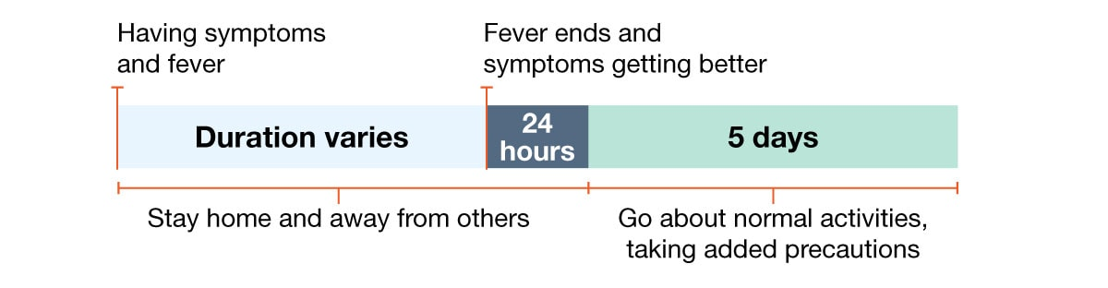
If on the morning of Wednesday July 29, 2026, your fever breaks, and symptoms get better throughout the day you may attend Summer BOW while wearing a mask and IF private housing is available (cabin, tent, camper, lodge). We will request you eat your meals in the picnic pavilion and remain 6 feet from other participants whenever possible.
Please inform the BOW coordinator immediately upon potential or actual inability to attend. Adjustments must be made to class supplies, schedules, catering, and lodging for the weekend.

