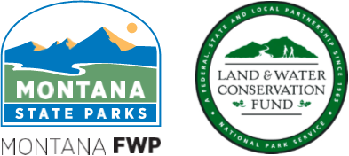

Montana Land & Water Conservation Fund
Pre-Application Project Proposal Form

Prospective LWCF Program applicants must complete and email this Pre-Application Project Proposal Form to the LWCF Program Manager before applying to the LWCF Program. The LWCF Program Manager will review your submission and contact you to conduct a 30-minute Pre-Application Meeting. During this meeting, the LWCF Program Manager will provide feedback about your proposed project and review important LWCF Program requirements with you.

Prospective applicants should review the LWCF Program Guidelines on the program website before completing this form: http://stateparks.mt.gov/recreation/lwcf.html

Complete all questions and email this form to Michelle McNamee, the LWCF Program Manager, at least two weeks before applying to the LWCF Program: michelle.mcnamee@mt.gov

Applicant (Subrecipient) Organization Name:
Eligible applicants may include incorporated cities or towns, counties, school districts, and tribal governments.
Proposed Project Name:
Brief Overview of Project Goals:
Provide a few sentences about what you plan to accomplish with LWCF funding.
Proposed Project Type: Land Ownership of LWCF Site (check all that apply):
 | Property Acquisition |  |  | City/Town
 | Development |  |  | School
 | Both of Above |  |  | County
 |  |  |  | State

Brief Description of Project Site:
Provide a few sentences about the project site (where it is situated and the current condition of the site).
Anticipated LWCF Funding Request Amount:
Anticipated LWCF Match Amount:
List your match funding sources, amounts, and if the funding is committed or anticipated:

When will you submit your LWCF Application?
When do you hope to break ground on this project?
Whom should the Program Manager contact about a Pre-Application Meeting?
Contact Name:
Contact Title/Affiliation:
Email Address:
Phone Number:

Additional Comments (if desired):

